Customs

Palm Sunday
Although Leafield has always been outside the boundaries of Wychwood Forest, it had a number of customs, some associated with the surrounding forest. On Palm Sunday folk went into the forest to a spring called Worts Well, or "Uzzle". They took with them bottles containing a spoonful of brown sugar, a piece of liquorice and a black peppermint. At the spring they filled the bottles with water, the resulting concoction was used as a general "cure-all". Wild liquorice plants grow next to Worts Well; it is thought that before the introduction of black liquorice, this plant was used as the basis for the concoction.
John Kibble, a local historian who wrote in 1928, records that prayers were said at the spring:
"Hast then a wound to heal; The wych doth grieve thee?
Come then unto this welle, It will relieve thee:
Nolie me tangeries, And other maladies"

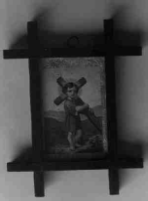
Church attendance on Palm Sunday reward
The local clergy did not approve of the custom. One Leafield villager has a crucifix picture given to her grandmother by the vicar, as a reward for being the only child to attend church on Palm Sunday, instead of going to the forest!

The Licensed Deer Hunt
Until about 1854 an annual deer hunt was held in the forest on Whit Monday. The woven bark horn used during the hunt is preserved in the Oxfordshire Museums Service store at Standlake. Henry Franklin of Leafield described the hunt to Percy Manning, a local historian, in the early years of this century. He said that his father had told him that in the old days people belonging to the parishes of Hailey, Crawley, Curbridge and Witney were allowed to cut their wood from Chase Woods, but after the Duke of Marlborough had acquired the land this privilege was stopped and the deer hunt permitted instead. The villagers were not allowed to shoot the deer, but had to run them. They came armed with sticks and brought lurcher dogs. When they caught a deer the first up had the right to cut its throat and keep the neck and head for himself; the carcass was then allotted to one of the four parishes. Although Leafield was not one of the four parishes, Field Towners evidently joined in the hunt. One year the deer jumped right into Henry Franklin's arms. He thought he had caught it, but the deer was too strong for him and knocked him flat!

The Mummers Play
Leafield also celebrated other customs widespread throughout the country. Leafield also had its own Mummers play. A rather corrupted and probably incomplete transcript of was recorded by R.J.E. Tidy in 1923. The characters in the play are the Foreman, the King of Prussia (King George?), a Duke, a Doctor, Jack Finney and the Drummer. A copy of Tidy's transcript can also be found on web site http://members.tripod.co.uk/Sandmartyn/mum.19.htm.

Leafield Feast and Club Day
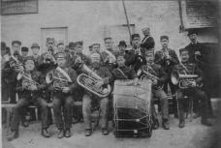
Leafield 5 Year Club, a village benefit and sick club, was established in 1784. The first Sunday after Whit Sunday was club day at Leafield, when there was a share out of moneys that had been paid in throughout the year. It was part of a weekend holiday, sometimes referred to in the nineteenth century as Leafield Feast, marked by celebrations and drinking, which sometimes ended with fights on the Greens. There was a parade round the Greens, led by the Leafield brass band. The banners of the various public houses were carried in front and behind the band and the villagers followed in the rear. Other events during this traditional holiday included dinners for the men, tea-parties for the women and children and dancing. John Simpson Calvertt often led Club Day and the Leafield Feast in his dairies; initially he appears put out by the lack of work done on his farm during the weekend, but from 1892 apparently mellowed towards it and habitually attended the dinners held at the local pub. Between at least 1911 and 1929, Packers, the photographers based at Chipping Norton, sometimes came out to Leafield to photograph the festivities.

Other festivities and events at Leafield
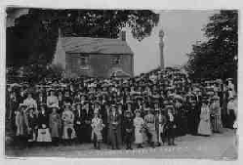
Other Leafield festivities of the period up to the 2nd World War were also recorded by Packers the photographers. In 1912 there was a meeting of the Girl's Friendly Society, when over 100 young women posed around the village cross. In 1923 a gymkhana was held in the village and the hunt also met at Leafield from time to time.
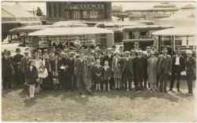
Fêtes or carnivals held between at least 1927 and 1939 were also high spots in the year. A 1927 photograph shows entrants for a fancy dress competition. In the summer a Sunday school outing to the seaside was arranged; usually the destination was Weston or Southsea. Several of Back's coaches were hired and most of the villagers would attend.

The Stocks
There was at one time a pair of stocks on the Greens. According to an article in the Oxford Times for 21 February 1952, the last man to be placed in the stocks at Leafield was a carpenter and he cut himself out with a saw. The stocks were then destroyed, but part of the ironwork was in the possession of John Kibble, the local historian, who died at the beginning of 1952.

