Houses
From the sixteenth century to the eighteenth, when a person died and his will had to be proved it was customary for an inventory to be made of all his moveable goods. They were often compiled room by room and give a fascinating picture of how houses were furnished. The Oxford Record Office has many inventories for people who lived at Leafield, most dating from the seventeenth century.
In some cases we can trace in which houses the people named in inventories they lived. Most of the old houses in Leafield give the outward appearance of having been built in between the seventeenth and nineteenth centuries, but some were partially rebuilt from an earlier core. The group of old cottages including the Leazings on the west side of Witney Lane, for example, has been extended from a medieval hall-house of c 1380-1440. The 1609 survey lists 22 houses; 6 of them, mostly the larger ones, were described as messuages and 18 as cottages.
Larger Houses
Many houses were bigger than these, 4 rooms being fairly common, but some were larger still. One of the richest people living in Leafield in the seventeenth century was John Harris, a weaver, who died in 1613. The value of the goods listed in Harris's inventory totalled over £300. He lived in Lowborough House, which he leased, which was probably then newly built as it is not mentioned in the 1609 survey. The house had many rooms and outbuildings including the hall, the kitchen, the buttery, the chamber within the hall, the chamber over the hall, the chamber over the kitchen, a garner or grain store, a mill house and a kill house. The rooms were much more comfortably furnished; the items are too numerous to list but included a number of luxury items such a carpet, 12 cushions, curtains, a cupboard with wainscot and a Bible and other books. As well as being a weaver, he evidently farmed on a large scale for he owned 124 sheep, 16 lambs, 6 pigs, a team of horses, farm equipment and a crop of corn yet to be cut worth £70.
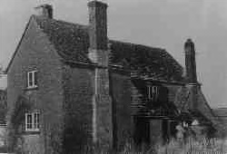
Another wealthy individual was Thomas Ashworth, a farmer who died in 1679. His goods were worth £120. He owned two houses. The first was Potash House, (or Pot House as it is now called) at the junction of Witney Lane and Buttermilk Lane. The second, the house in which he lived, was the Slatt House, later known as Lower End Farm, the buildings of which have now been converted into a group of individual houses. The rooms in the Slatt house included the hall, the dining room, the study (not perhaps so grand as it sounds since it contained a still as well as books!), the kitchen, the buttery, the red chamber, the hall chamber and the garret. All were lavishly furnished; the red chamber, for example, contained a bedstead with curtains and valence, a table, 6 chairs, a carpet, a rug and a looking glass. There was a clock in the hall and he owned a watch, both rarities at this time.

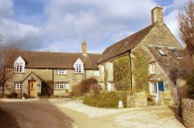

Lower end farm converted into modern houses

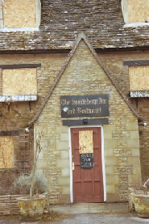
The 'Potters Arms' renamed to 'Brahms and List' then 'Spindleberry Inn and Restaurant'

Leafield Cottages
Most Field Towners were humble folk with few possessions. Many would have been too poor for an inventory to be made but the better off cottagers, the Surmon family are perhaps typical. John Surmon and his elder son Stephen lived in a pair of similar cottages in Purrants Lane built from the ruins of a mediaeval building in 1602 by John, who was a carpenter.
John lived in the cottage now known as Purrants Cottage, which in the last 150 years has been extensively rebuilt and extended. John's inventory, made in 1625, does not say what was in each room, but lists all his tools including 2 saws, 2 axes, 3 augers, 2 chisels, a spoke shave, an adze, a square and 3 wedges. His goods were worth £5 2s 6d.
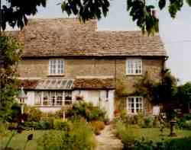
His son, Stephen, who lived in Dawn Cottage, was richer, the value of his inventory totalling £66 15s, but £50 10s of that was "money due upon land". The house was of single-cell construction and consisted of a hall, chamber over the hall, a cockeloft above the chamber and a stable. Stephen died in 1671 and his wife Edith 4 years later. In the upstairs chamber they had a bedstead with a flock bed and bedding including 3 pairs of sheets, 2 chests or coffers and a press (an early type of cupboard). In the hall downstairs they had a table, a cupboard and a chair "with other small lumber"; this presumably included at least one stool, or only one of them would have been able to sit down at a time! Their brass and pewter is lumped together in the inventories but Edith's will mentions a large brass kettle, 2 pewter platters, a brass pot and a brass warming pan.

Lower end pre 1905
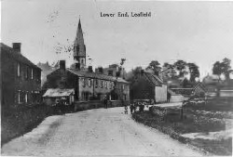

Lower end post 1905
